CHAPTER 18 | Public Choice, Taxes, and
the Distribution of Income
Solutions to End-of-Chapter Exercises
18.1 | Public Choice  Learning Objective: Describe the public choice model and explain how it is used to analyze government decision making.
Review Questions
1.1 The public choice model applies economic analysis to government decision making.
1.2 The voting paradox is the failure of majority voting to always result in consistent choices. The Arrow impossibility theorem is a mathematical theorem that holds that no system of voting can be devised that will consistently represent the underlying preferences of voters.
1.3 Rent seeking is the attempt by individuals and firms to use government action to make themselves better off at the expense of others. Regulatory capture is one way of accomplishing rent seeking; it allows firms to influence the decisions made by a regulatory agency so that the decisions will be in the best interest of the firms, rather than in the best interest of the public.
1.4 Market failure is a case in which the market fails to provide the economically efficient outcome. Government failure is a case in which government intervention in a market causes an outcome that is not economically efficient. Although government intervention can sometimes increase economic efficiency, it can also sometimes cause economic efficiency.
Problems and Applications
1.5 In this case, there is no voting paradox because both David and Kathleen prefer mass transit as their first choice. This means that in any two-way vote David and Kathleen will vote for mass transit and that will be the outcome, so transitivity holds in this case.
1.6 The median voter theorem states that the outcome of a majority vote is likely to represent the preferences of the voter in the political middle. In the primaries, the only voters the politicians need to be concerned with are the ones in their own party, and therefore, politicians direct their attention to the median voter of this selected group. In the Republican Party, the median voter is more likely to be more conservative than the median voter in the broader electorate; and in the Democratic Party, the median voter is more likely to be more liberal than the median voter in the broader electorate. But once politicians have received their party’s nomination, candidates will emphasize policies that are likely to appeal to the median voter in the electorate as a whole.
1.7 An economist would disagree with this argument because the median voter theorem will hold in both cases. Majority rule will ensure that the politicians will aim for the median voter whether or not preferences among other voters are similar to or very different from those of the median voter.
1.8 The assumption that government officials are merely human means that although they are elected to carry out the wishes of the voters, the officials may instead act in their own best interests. For example, rent seeking by domestic producers in the sugar industry resulted in a quota being placed on sugar imports. This quota raised profits for domestic producers, but at the expense of reduced consumer surplus and reduced economic efficiency. In addition, regulatory agencies that become “captured” by the industries they are supposed to regulate may end up hurting consumers by reducing (instead of increasing) the amount of competition that exists within the industry. Politicians benefit from the campaign contributions and other favors they receive from these “special interests,” which can lead them to act in ways that are not favorable to the public as a whole.
1.9 a. Government failure means that sometimes government intervention may reduce economic efficiency rather than increase it. Public choice theory suggests that government could fail systemically due to rent seeking, logrolling, and regulatory capture.
b. The expression “rent seeking” describes the efforts by individuals and firms to use government action to make themselves better off at the expense of others. Rent seeking may be useful when thinking of policy because, as with the case of the quota Congress placed on sugar imports, a policy can benefit a few (U.S. sugar producers) at the expense of others (higher prices to consumers of sugar and to firms, such as candy manufacturers, that use sugar as an input).
1.10 The typical person is likely to gather more information when buying a new car because he or she will be significantly and immediately affected by this decision. When voting for a member of the House of Representatives, the person is only one of many voters and his or her vote is therefore diluted among all other votes and is likely to have very little effect on the outcome of the election. As a result, people have little incentive to invest the time and energy in gathering as much information about the candidates as about a car.
1.11 In a marketplace, people pursue their interests through the choices of what to sell or buy. In politics, people pursue their interests by trying to influence politicians, regulations, votes, or election outcomes. In the business marketplace, people can choose not to purchase or sell a good. In the political marketplace, once the decision has been made to provide the good, everyone must pay for it and, in the case of public goods, receive it. Individual preferences are therefore more clearly defined in the business marketplace.

18.2 | The Tax System  Learning Objective: Understand the tax system in the United States, including the principles that governments use to create tax policy.
Review Questions
2.1 As Figure 18.2 on page 575 shows, individual income taxes raise the most revenue for the federal government. And, as also illustrated in Figure 18.2, in 2012 grants from the federal government raised the most revenue for state and local governments.
2.2 A progressive tax is a tax for which people with lower incomes pay a lower percentage of their income in tax than do people with higher incomes. A regressive tax is a tax for which people with lower incomes pay a higher percentage of their income in tax than do people with higher incomes. Because President Obama and Congress passed legislation in 2012 that raised tax rates on families earning $450,000, the tax system is now more progressive.
2.3 A marginal tax rate is the fraction of each additional dollar of income that is paid in taxes. An average tax rate is the fraction of all income that is paid in taxes. Because people make their decisions by comparing marginal costs to marginal benefits, the marginal tax rate plays a bigger role than the average tax rate in influencing economic behavior. For example, when contemplating whether or not to work an extra hour, a person will make the decision based on the after-tax wage earned from working that hour, which is found by multiplying the marginal tax rate by the wage rate and subtracting the result from the wage rate.
2.4 In deciding which taxes to use, a government will consider the effect of the tax on economic efficiency (whether the tax inflicts a small or large deadweight loss); the ability-to-pay principle (whether people who can afford to pay more do pay more); the horizontal equity principle (whether people in the same economic situation are treated equally); the benefits-received principle (whether people receiving benefits from a government project are the ones paying the taxes and fees to support it); and other social objectives (such as curtailing activities with high external costs).
Problems and Applications
2.5 One reason is that the total income earned by individuals is much greater than the total profits earned by businesses. Another reason is that taxes on businesses may have a large excess burden. See the Making the Connection on page 582 about the corporate income tax.
2.6 A tax is regressive if people with lower incomes pay a higher percentage of their income in tax than do people with higher incomes. A tax is progressive if people with lower incomes pay a smaller percentage of their income in tax than do people with higher incomes. Based on the data in the question, the federal cigarette tax is regressive.
2.7 The lottery “tax” is generally considered to be regressive because data show that poorer people spend a greater share of their incomes on lottery tickets than do people with higher incomes. The data we need to determine if the burden of a lottery is progressive or regressive are the percentage of income people in each income bracket spend on the lottery.
2.8 a. The person earning $25,000 will have a total tax of $3,303.75:
0.1 × $8,925 = $892.50 plus
0.15 × $16,075 = $2,411.25
The marginal tax rate is 15 percent; the average tax rate is ($3,303.75/$25,000) × 100 = 13.22 percent.
b. The person earning $125,000 will have a total tax of $28,293.25:
0.1 × $8,925 = $892.50 plus
0.15 × $27, 325 = $4,098.75 plus
0.25 × $51,600 = $12,900.00 plus
0.28 × $37, 150 = $10,402.00
The marginal tax rate is 28 percent, and the average tax rate is ($28,293.25/$125,000) × 100 = 22.63 percent.
c. The person earning $300,000 will have a total tax of $83,130.75:
0.1 × $8,925 = $892.50 plus
0.15 × $27,325 = $4,098.75 plus
0.25 × $51,600 = $12,900.00 plus
0.28 × $95,400 = $26,712.00 plus
0.33 × $116,750 = $38,527.50
The marginal tax rate is 33 percent, and the average tax rate is ($83,130.75/$300,000) × 100 = 27.71 percent.
2.9 a. No. The highest 1 percent of U.S. income earners paid 30.9 percent of their income in total federal taxes. Buffett’s secretary is likely to be in the third or fourth income quartile. These quartiles paid 19.3 percent and 26.1 percent of their income in total federal taxes. So, the typical person in the top 1 percent of incomes pays a larger fraction of his or her income in taxes than does the typical middle-income person.
b. A capital gain represents the difference between the price at which a person purchases an asset, such as a stock or bond, and the price at which the person sells the asset. For example, if someone purchased a share of stock for $40 and later sold it for $50, there would be a $10 capital gain. Some goals and principles that should be considered with regards to taxing capital gains at a lower rate would include the ability-to-pay principle, the horizontal-equity principle, and economic efficiency. In recent years, Congress has taxed capital gains at a lower rate than wage and salary income in order to provide a greater incentive for people to save and invest.
2.10 The proposal would make the federal income tax system more progressive. In 2013, income above $113,700 was not subject to the payroll tax for Social Security, but this income is subject to the federal personal income tax. So if Social Security funding was to come from the federal personal income tax, any taxes paid on income above $113,700 would now be available to fund Social Security. People earning these higher levels of income would likely be contributing more to Social Security than they currently do. Of course, in the end, it depends on how Congress would adjust personal income tax rates in response to the loss of revenues from the payroll tax.
2.11 Food is often exempt from taxation because of the ability-to-pay principle. Poorer households generally spend a much larger fraction of their incomes on food, which is a necessity. In satisfying these basic needs, they don’t have as great an ability to pay taxes as households with higher incomes. The exemption of services from sales taxes is much harder to understand using the principles of taxation. Taxing services at a lower rate than goods can undermine the goal of achieving economic efficiency. It may be that the exemption of services is an effort to attain other social objectives. It is much easier for tax collectors to monitor the sales of goods, so the exemption may be the result of state legislators believing that a tax on services would be difficult to collect.
2.12 Eliminating the income tax will increase the after-tax income of everyone, which should lead them to purchase more normal goods. Automobiles are normal goods, so eliminating the income tax should (holding everything else constant) lead to more automobile purchases. However, imposing a consumption tax makes purchasing automobiles and all other goods and services more expensive relative to saving. Holding everything else constant, this effect tends to reduce automobile consumption. So, there are two effects that work in opposite directions. The effect of eliminating the income tax leads to more automobile purchases, while the effect of imposing a consumption tax leads to fewer automobile purchases. It is impossible to tell which of these effects is stronger, so we cannot tell if automobile purchases would increase or decrease.
2.13 a. At $15,000 income, the average tax rate ($0/$15,000 × 100) = 0%
At $30,000 income, the average tax rate ($4,500/$30,000 × 100) = 15%
At $45,000 income, the average tax rate ($11,250/$45,000 ×x 100) = 25%
At $60,000 income, the average tax rate ($21,000/$60,000 × 100) = 35%
At $75,000 income, the average tax rate ($30,000/$75,000 × 100) = 40%
b. In this example, because the average tax rate increases as income increases, the tax is progressive.
c. Because the average tax rate is rising between income of $60,000 and $75,000, the marginal tax rate for income of $65,000 has to be higher than the average tax rate of 35 percent, but one cannot determine the exact marginal rate.

18.3 | Tax Incidence Revisited: The Effect of Price Elasticity  Learning Objective: Understand the effect of price elasticity on tax incidence.
Review Questions
3.1 Tax incidence refers to the actual division of the burden of a tax between buyers and sellers in a market.
3.2 In general, if demand is less elastic than supply, buyers pay the larger share of the tax. If supply is less elastic than demand, sellers pay the larger share of the tax.
Problems and Applications
3.3 The statement means that laws stating that a particular group (for example, sellers) must pay a tax have little bearing on who actually pays the tax. The statement is correct. Even though a law may specify that a seller pays the whole tax, the economic logic explained in Figure 18.4 on page 582 in the text indicates that most taxes are borne partly by buyers and partly by sellers. After a tax is imposed, the price paid by buyers will generally rise and the price received by sellers after paying the tax will generally fall. The fraction of the tax borne by each group depends on the price elasticity of supply relative to the price elasticity of demand.
3.4 Although businesses officially pay federal corporate income taxes, all taxes must ultimately be paid by people. Taxes on businesses are borne partly by the owners of the businesses (whose investment return falls), partly by the employees of the businesses (whose wages fall), and partly by the customers of the businesses (whose pay higher prices).
3.5 Although on resale, the seller of a condo may be required to pay the tax, the burden of this tax is most likely borne partly by the seller and partly by the buyer. The seller of an existing condominium, knowing that he is responsible for paying the transfer tax, is likely to pass part of this tax along to the buyer in terms of a higher selling price. With a new condominium, the buyer is required to pay the transfer tax, but knowing this, the seller is likely to set a lower selling price. Whether it is a new condo or a resale, the burden of the transfer tax will be divided between the buyer and the seller.
3.6 As the textbook notes, because the corporate income tax reduces the returns to firms from investing, firms invest less, which reduces the amount of capital workers have to work with. When workers have less capital to work with, they are less productive. As we saw in Chapter 17, if labor productivity falls, the demand for labor declines. This decline is shown in the graph that follows by the demand curve for labor shifting to the left from D₁ to D₂. The equilibrium wage falls, so workers bear part of the burden of the corporate income tax. The deadweight loss is equal to areas A + B in the graph.
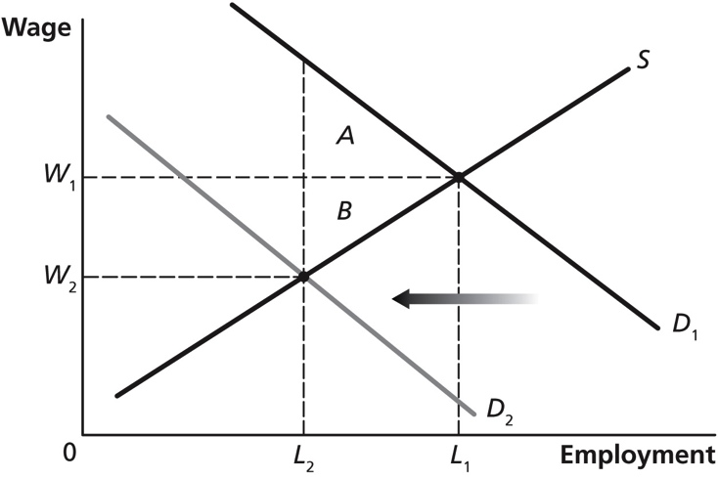
As long as the demand curve shifts to the left, there will be a deadweight loss. How far to the left the demand curve shifts will determine the size of the deadweight loss. Therefore, the size of the deadweight loss will be smaller if the size of the capital stock does not respond much to tax rates or if the quantity of capital goods available does not have a large effect on worker productivity.
3.7 The more inelastic demand is relative to supply, the more the burden of a tax is borne by the buyer. Because the beer industry believes the new tax on beer would raise the price of beer by 25 cents per half pint, the beer industry must believe the demand for beer is more price inelastic than the supply of beer (whereas the French government must believe the demand for beer is more price elastic than is the supply of beer).
3.8
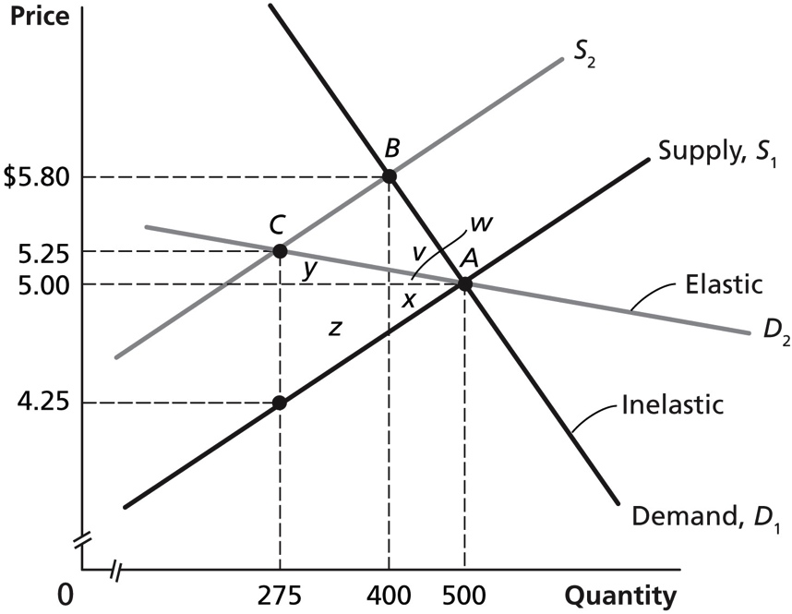
a. If the government wants to minimize the excess burden of excise taxes, the taxes should be imposed on goods whose demand is inelastic. In the graph above, the product has an equilibrium price of $5.00 (point A), and a $1.00 per-unit tax is imposed. On the elastic demand curve (D₂), the consumer will now pay a price of $5.25 (point C). The excess burden of the tax, which is the deadweight loss, is shown by the area of the triangle made up of w, x, y, and z. On the inelastic demand curve (D₁), the consumer will pay a price of $5.80 (point B). The excess burden of the tax in this case is shown by the area of the triangle made up of v, w, and x. The area of the deadweight loss is clearly smaller when demand is inelastic.
b. If the government is most interested in maximizing the revenue it receives from the tax, the taxes should be imposed on goods whose demand is inelastic. In the graph above, the tax per unit is $1.00. If demand is elastic, the tax revenue received by the government will be equal to the $1.00 tax times the quantity sold, which is 275 (point C), or $275.00. If demand is inelastic, the tax revenue received by the government will be equal to $1.00 × 400 (the quantity at point B), or $400.00.
c. If the government wants to discourage the consumption of a product, the tax will have more impact if the demand for the product is elastic. In the graph above, the $1.00 excise tax causes the quantity demanded to fall from 500 to 275 when demand is elastic, but the quantity demanded only falls from 500 to 400 when demand is inelastic.
3.9 a. The price consumers pay will rise more if the demand curve is less elastic, which would be demand curve D₂ in this case. In the following figure, the supply curve has shifted upward by 10 cents from S₁ to S₂. If the demand curve is D₁, then the price paid by consumers rises to $4.53. If the demand curve is D₂, then the price rises by more—to $4.57.
b. The revenue to the government will be greater if the demand curve is D₂ because the quantity sold is greater for D₂ (Q₂) than for D₁ (Q₁).
c. The excess burden will be greater if the demand curve is D₁—which is more elastic. With demand curve D₁, the excess burden is the area = b + c + d + e. With demand curve D₂, the excess burden is the area = a + b + c. The area of d + e is clearly greater than the area of a.
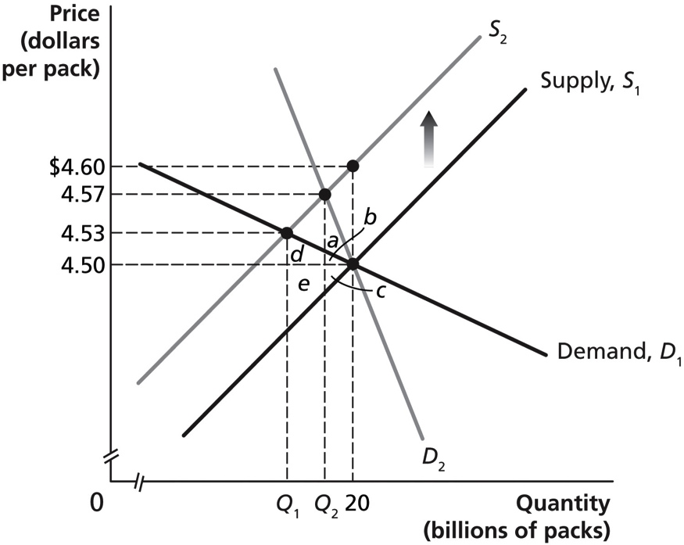
3.10 You should disagree with that statement. The more elastic the supply curve, the greater the excess burden of a tax. Figures 1 and 2 that follow show the excess burden of a tax when supply is more elastic (Figure 1) and when supply is less elastic (Figure 2). In each graph, the equilibrium price and quantity before the tax are $10 and 10 units. In each figure, a $2.00 per unit tax will shift the supply curve from S₁ to S₂. The excess burden in each graph is represented by areas A + B. Using the formula for the area of a triangle, ½ length times height, the value of the area for A + B in Figure 1 is [½ × (2 × $1.00) + ½ × (2 × $1.00)] = $2.00. The value of the area for A + B in Figure 2 is [½ × (1 × $0.20) + ½ × (1 × $1.80)] = $1.00. The area representing the excess burden is greater in Figure 1, where supply is more elastic, than in Figure 2, where supply is less elastic.
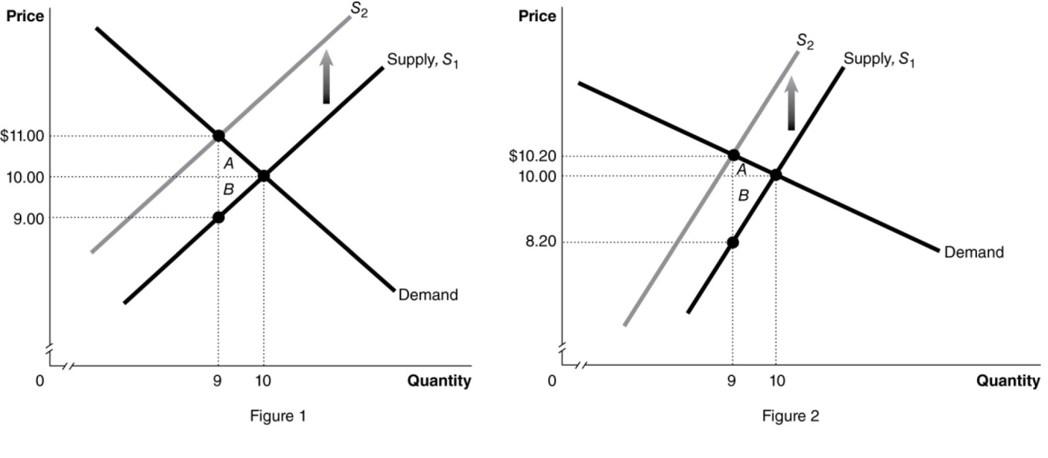

3.11 a. The vertical distance between the supply curves indicates the amount of the per unit tax, so in this case the tax is $4 per pizza.
b. Before the tax, consumers pay $10 per pizza. After the tax, consumers pay $12 per pizza (found by locating where the new supply curve, S₂, intersects with the demand curve).
c. Before the tax, sellers receive $10 per pizza. After the tax, sellers receive $8 per pizza (which is the difference between the $12 price consumers pay after the tax and the $4 tax per pizza the government receives).
d. Of the $4 per pizza tax, consumers pay $2.00 (the difference between the price consumers pay before the tax and after the tax). Because consumers pay $2.00 of the $4 tax, producers pay the other $2.00 of the tax.

18.4 | Income Distribution and Poverty  Learning Objective: Discuss the distribution of income in the United States and understand the extent of income mobility.
Review Questions
4.1 In the United States, the top 20 percent of households earn about 50 percent of income before taxes and transfers, while the bottom 20 percent of households earn about 3 percent of income. Income inequality declined modestly during the middle of the twentieth century, but increased somewhat after 1980.
4.2 The poverty line is the level of annual income equal to three times the amount necessary to purchase the minimal quantity of food required for adequate nutrition. The poverty rate is the percentage of the population that falls below the poverty line. The poverty rate fell from 22 percent to 11 percent between 1960 and 1973 but has not changed much over the past 40 years. The poverty rate was 15 percent in 2012.
4.3 The Lorenz curve is a curve that shows the distribution of income by arraying incomes from the lowest to the highest on the horizontal axis and indicating the cumulative fraction of income earned by each fraction of households on the vertical axis. The Gini coefficient is equal to the area between the line representing perfect income equality and the Lorenz curve divided by the whole area below the line of perfect equality. A lower Gini coefficient shows a more equal income distribution. If the country had a Gini coefficient of 0.48 in 1960 and 0.44 in 2014, income inequality would have decreased during these years.
4.4 According to the marginal productivity theory of income distribution, the distribution of income is based mainly on the marginal revenue product of the factors owned by households. In this view, income inequality is determined by the quantities of factors owned by households (including labor, capital, and natural resources) and the prices of these factors of production (which are determined by the interaction of demand and supply). Income inequality has risen over the past three decades. This increase is partly due to the wage rates earned at the top end of the income distribution having risen in comparison to those at the bottom end, largely because of the effects of technological change and the globalization of markets. Government policies, especially those dealing with taxes and transfers, also have an effect on income inequality.
4.5 Generally speaking, income in the United States is distributed less equally than in other high-income countries.
4.6 There has been a substantial decline in the global poverty rate since 1970. In 1970, about 27 percent of the world’s population lived in poverty. By 2006, this proportion had fallen to 5 percent. Much of the decline occurred in Asia.
Problems and Applications
4.7 a. Pretax incomes are the incomes people receive before they pay taxes.
b To the extent that earnings provide an incentive to work, save, and invest, some income inequality may be desirable as a characteristic of economic growth. Whether the gains from income inequality offset the losses is a normative question.
4.8 If the federal government wants to guarantee equality of economic outcomes, it needs to make sure the earnings of given activities are the same for all individuals performing these activities. The government could ensure that the distribution of income was completely equal by enacting a tax rate of 100 percent on income and then distributing the tax receipts equally among people. This policy would benefit the poor, to some extent, as their incomes would probably rise, but society as a whole would lose, as there would be no incentive to work hard or innovate, and the production of goods and services would decrease significantly
4.9 This is good news because (1) everyone has the opportunity to invest in skills and (2) the more skills people possess, the greater their productivity, and the greater the amount of goods and services that are produced.
4.10 a. The distribution of income became less equal in 2014. The Lorenz Curve for 2014 is farther away from the diagonal line of equality than is the Lorenz Curve for 2013.
b. The Gini coefficient = (the area inside the Lorenz curve)/(the area beneath the diagonal line of equality). Thus, for 2013, the Gini coefficient = A/(A + B + C) = 2,150/5,000 = 0.43. For 2014, the Gini coefficient = (A + B)/(A + B + C) = 2,400/5,000 = 0.48.
4.11
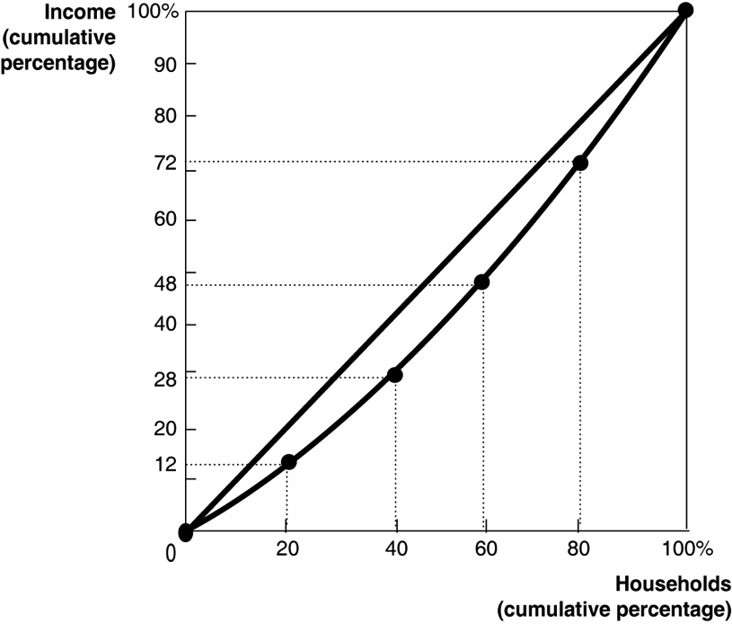
The total income of this group is $250,000.

Quintile Share of Income Cumulative Share of Income
Lowest 20% (Lori) 12% 12%
Second lowest 20% (Jerome) 16 28
Middle 20% (Steve) 20 48
Second highest 20% (David) 24 72
Highest 20% (Lena) 28 100
4.12 Economists like to examine both absolute poverty—measured in dollars or the amount of goods and services that a household can buy in comparison to an objective measure of the amount needed to survive or experience an adequate quality of life—and relative poverty—measured in comparison to the overall average of a society. The $1.00-per-day standard of living is a useful measure of absolute poverty because it is very difficult for someone to survive or have an adequate quality of life with an income below $1.00 per day (although some people do). If this standard of poverty were used for rich countries, like the United States, virtually no one would be considered as living in poverty. However, many people in the United States live at a standard that is considered poor by the high standards of the country. To measure this kind of poverty, a higher standard is used, such as the $23,550 per year standard for a family of four with two children. Such families do not live in the absolute poverty of people trying to get by on $1.00 per day, but they are considered relatively impoverished by people in their country. Likewise, the American poverty standard wouldn’t be very useful for people in sub-Saharan Africa. A family of four with two children living on $23,550 per year in a country like Nigeria would be considered very well off by its fellow citizens.
4.13 It is extremely unlikely that the incomes of the poor would rise by $6,000. Faced with the higher marginal tax rate, rich households are likely to work less, earn less, and thus pay less than $6,000 each in taxes. Similarly, many poorer households will respond to the transfer by working less, so their pre-transfer labor market earnings will fall below $20,000.
4.14 The poverty line is defined as an annual income equal to three times the amount necessary to purchase the minimal quantity of food required for adequate nutrition—and it is calculated before taxes and transfers. There are many reasons why consumption and ownership of these goods could rise while poverty rates stay the same. Most importantly, the poverty rate is based on income, and consumption can differ from income due to transfer payments, for example. Another reason is that the definition of “adequate” nutrition seems to have risen over time, increasing the purchasing power of those at the poverty line.
4.15 While policies to redistribute income may be needed in the United States, it doesn’t seem to be true that the more than 15 percent of the population that is currently poor has no hope of ever climbing above the poverty line. The chapter cites a study by the U.S. Census Bureau that found that of people who were poor at some time during the years 2004 to 2006, about half were in poverty for four months or less. Of the people who were poor in January 2004, only about 23 percent remained in poverty every month through December 2006. Only 2.8 percent of the U.S. population was poor every month during those three years.

